Name : Sakthi Manoj R Reg No : 192324236
PROGRAM 18
Create Different Graphs in R
Aim:
To create and display a boxplot, histogram, bar plot, line chart, and scatter plot in R.
Procedure:
Step 1: Open RStudio or the R console on your computer.
Step 2: Create two numeric vectors containing values for plotting.
Step 3: Use par(mfrow = c(2, 3)) to arrange multiple plots in one plotting window.
Step 4: Create a boxplot to show the distribution of the data.
Step 5: Create a histogram to visualize the frequency distribution.
Step 6: Generate a bar plot with labels to compare values across categories.
Step 7: Draw a line chart to show the trend of values sequentially.
Step 8: Create a scatter plot to visualize the relationship between two numeric variables.
Step 9: Observe all graphs in the multi-plot layout.
Output :
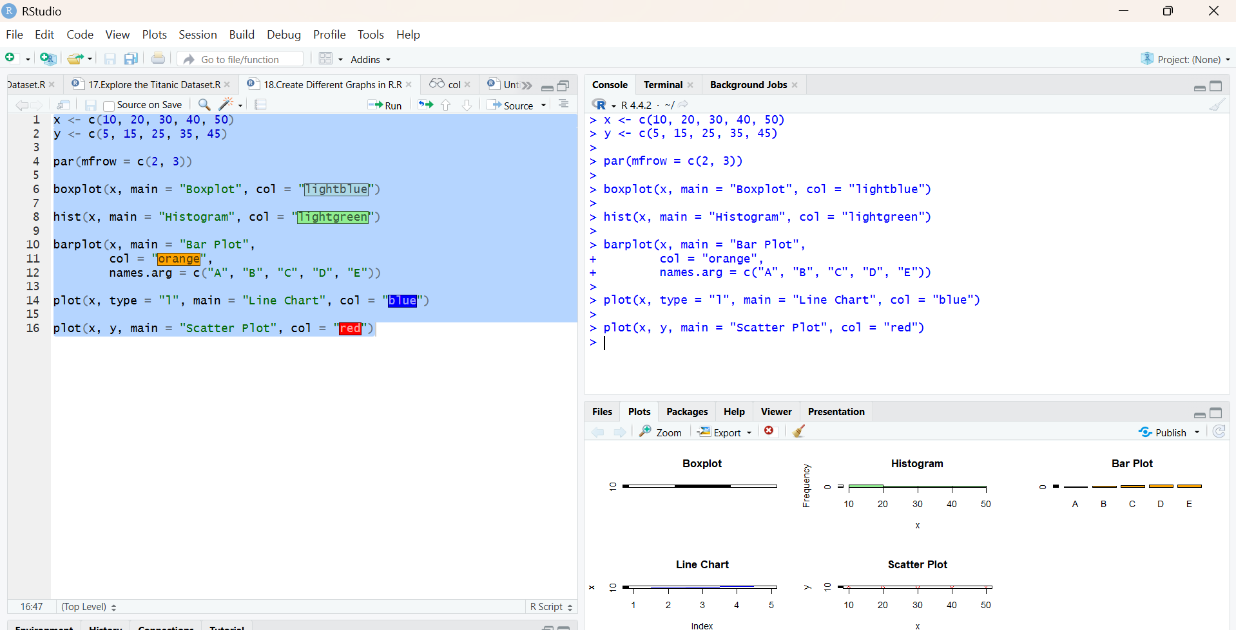
Result:
Hence the output is verified successfully.

